SPSS TUTORIALS
https://www.spss-tutorials.com/spss-sign-test-for-one-median-simple-example/
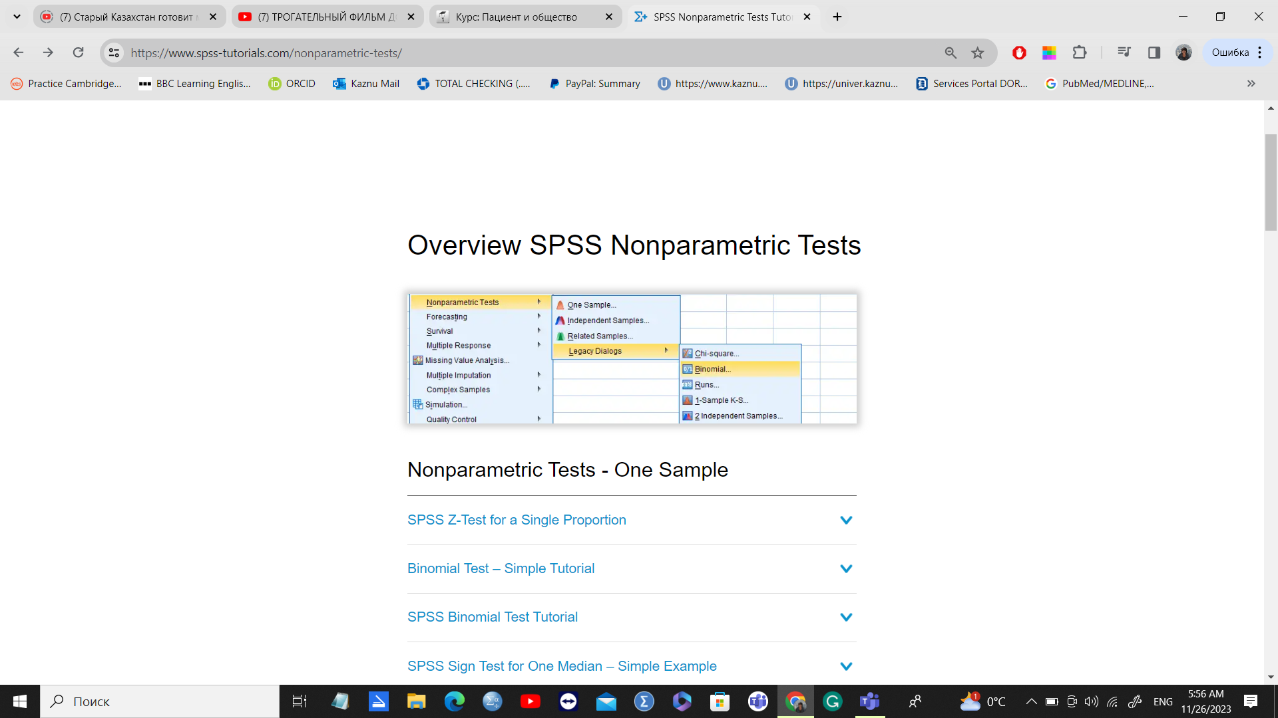
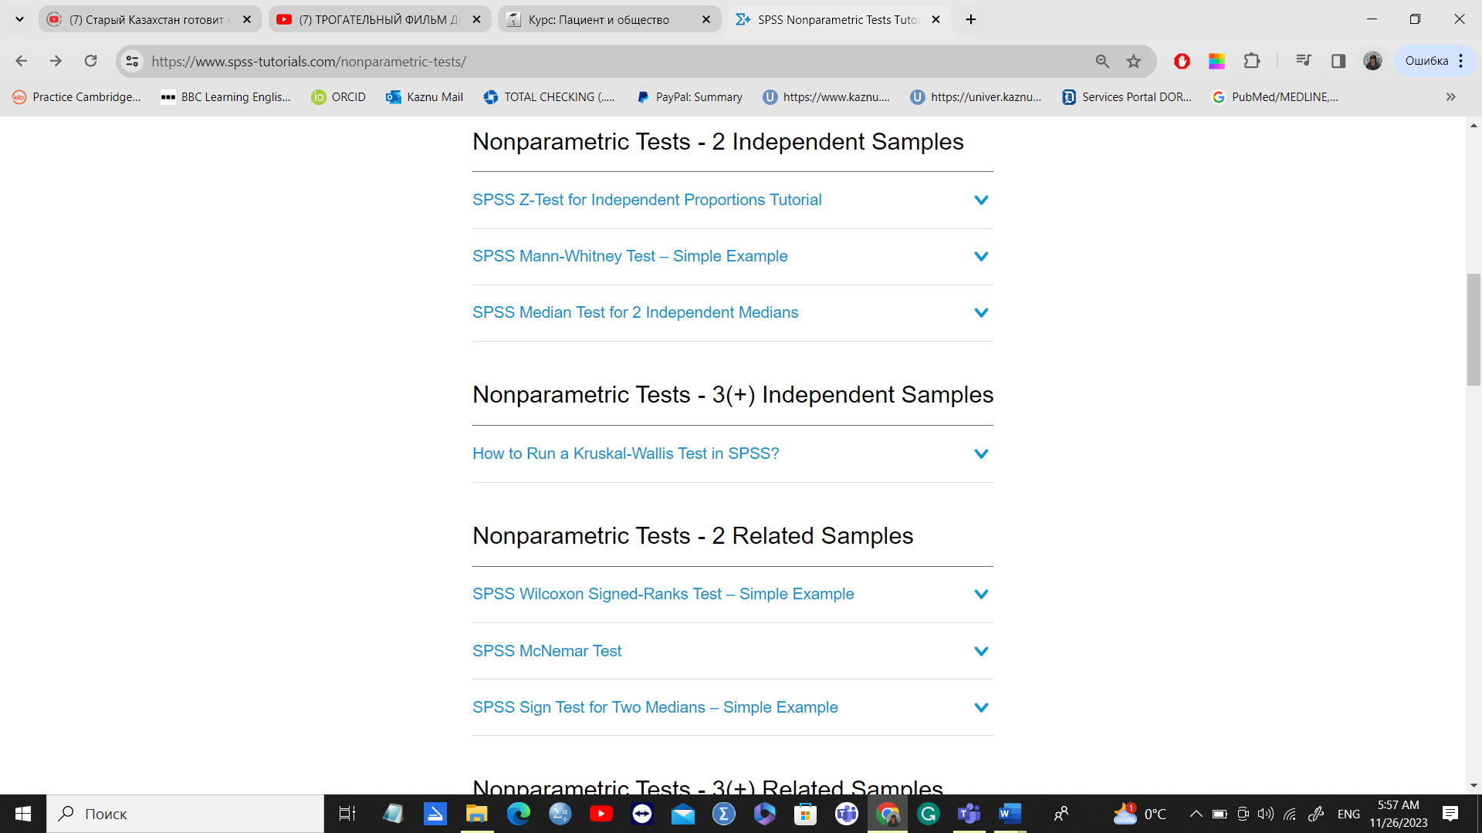
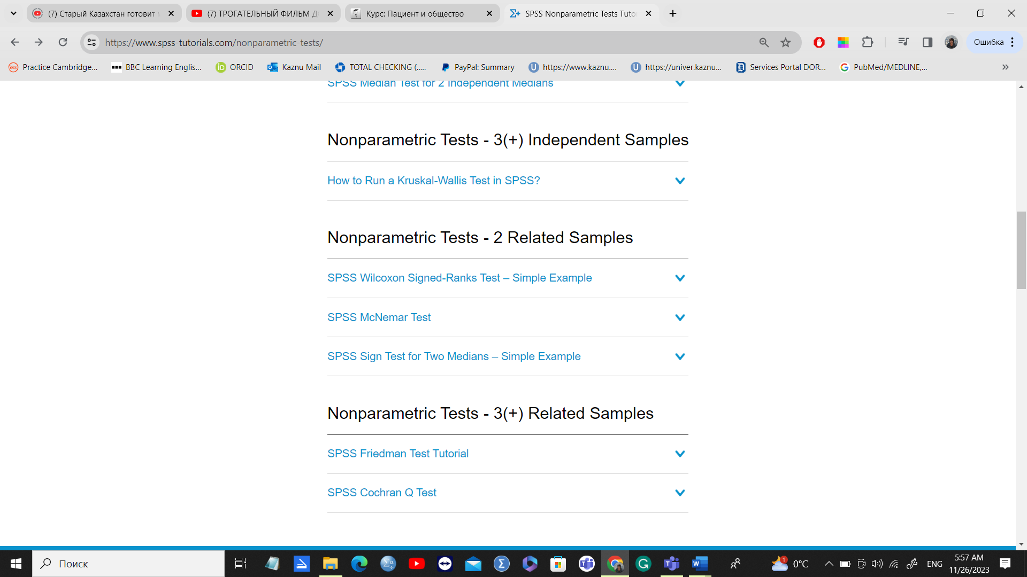
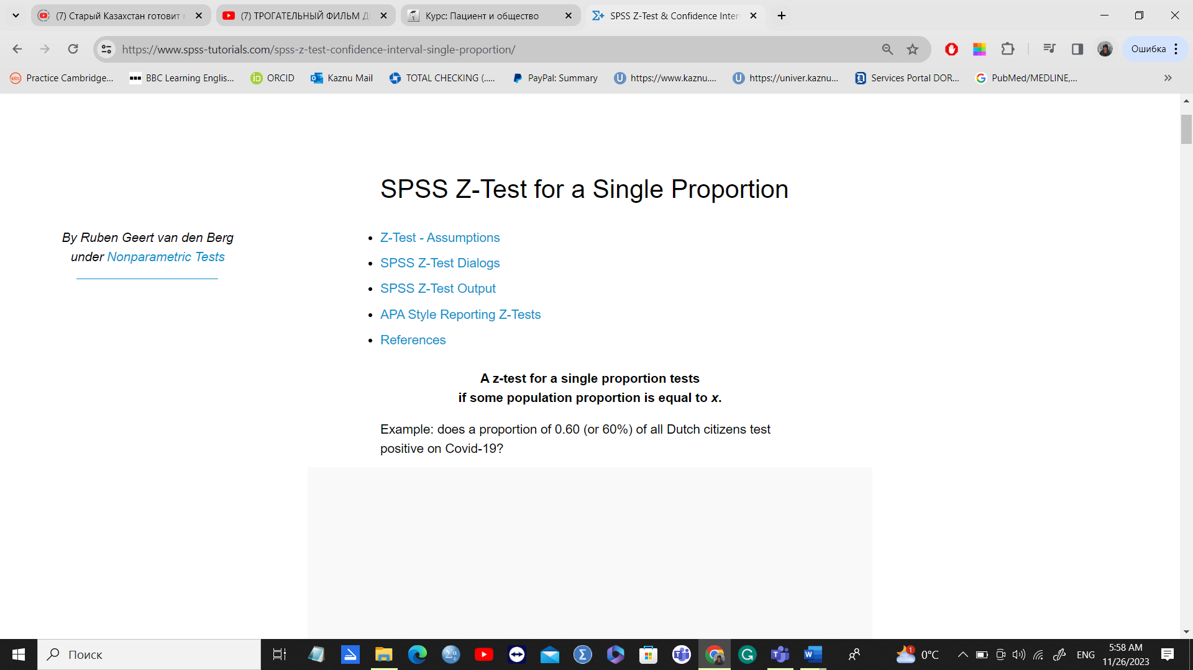
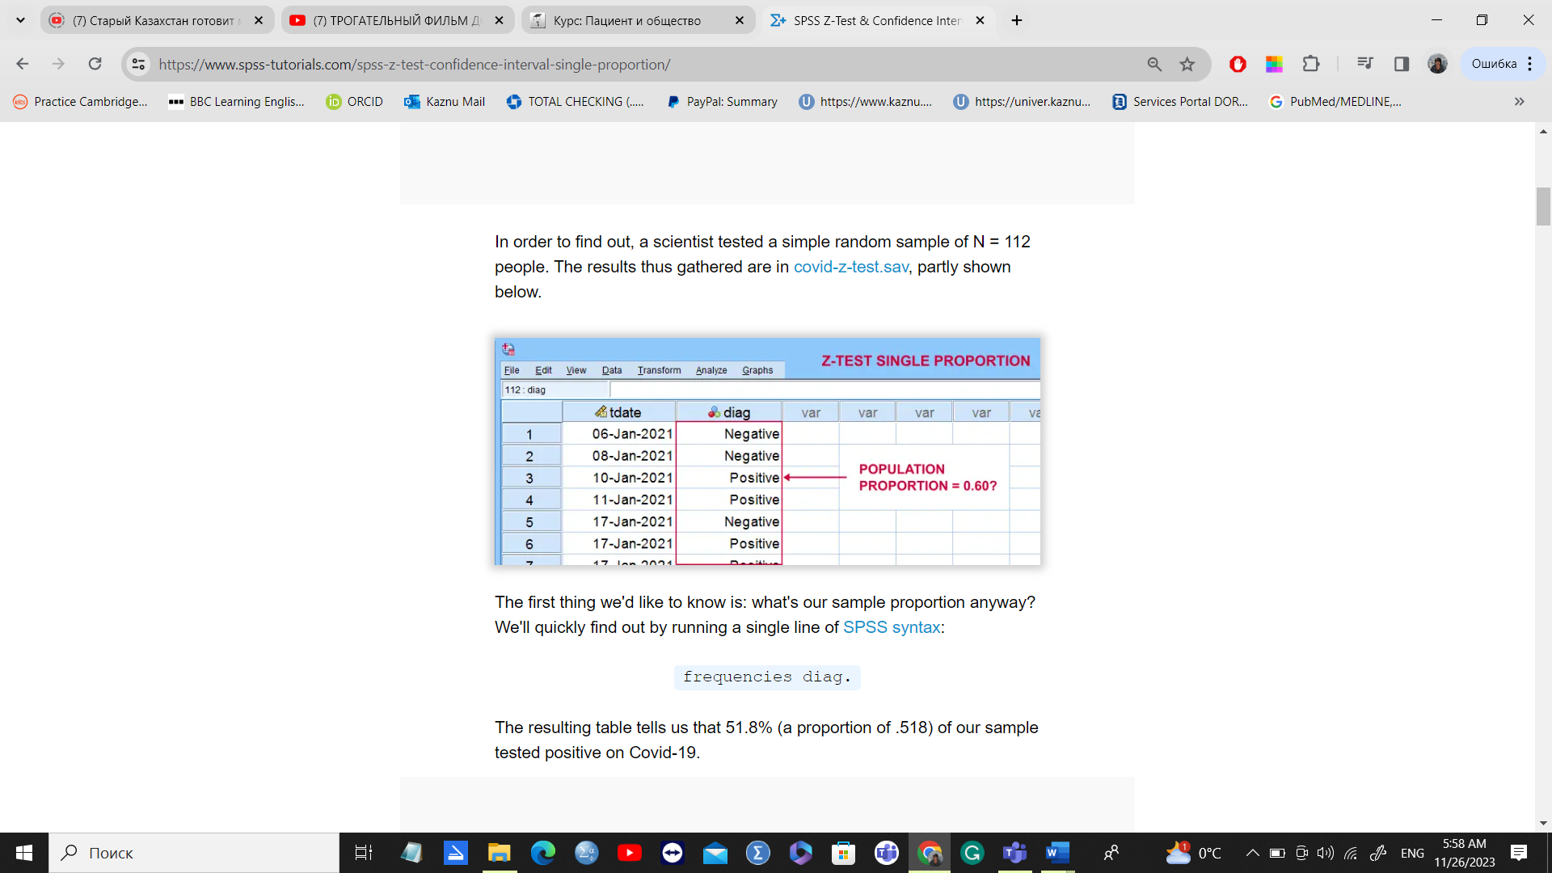
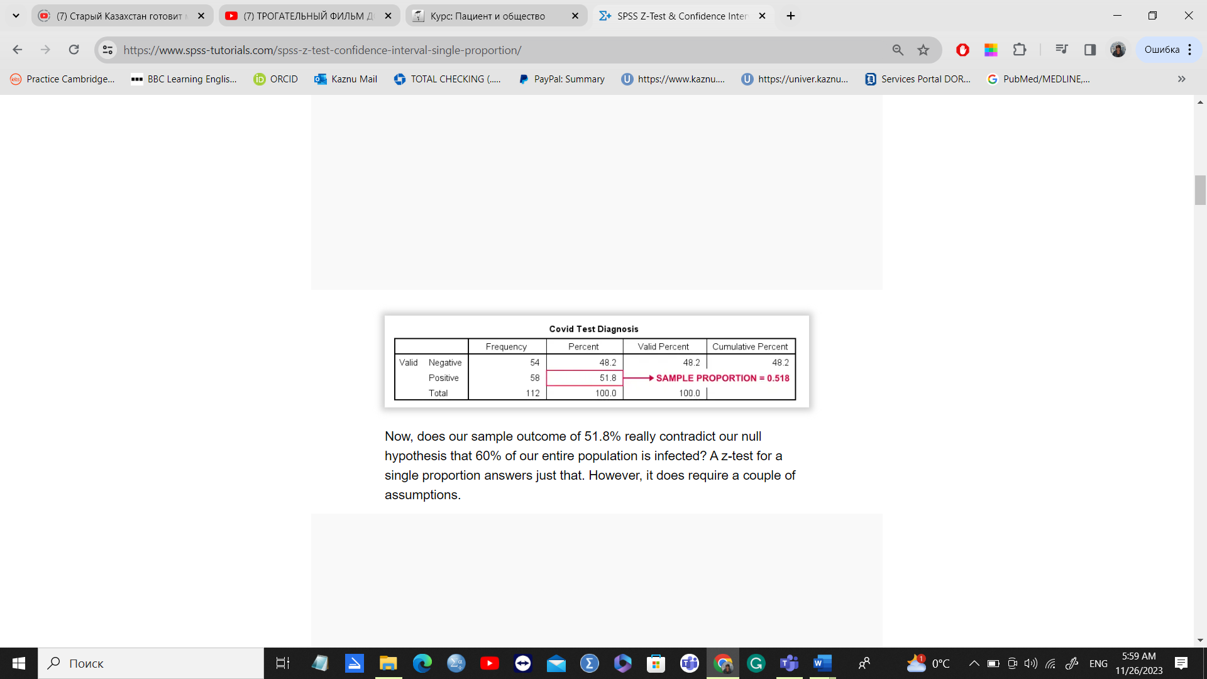
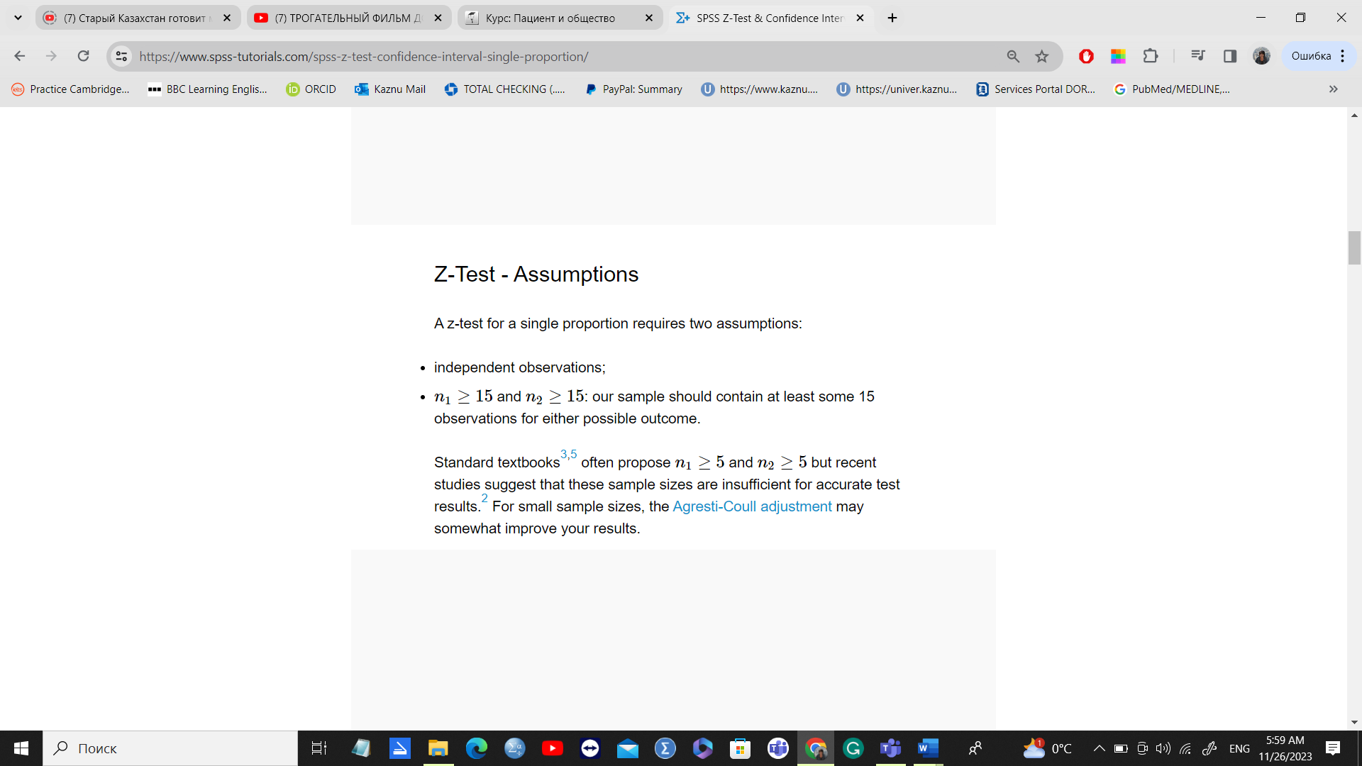
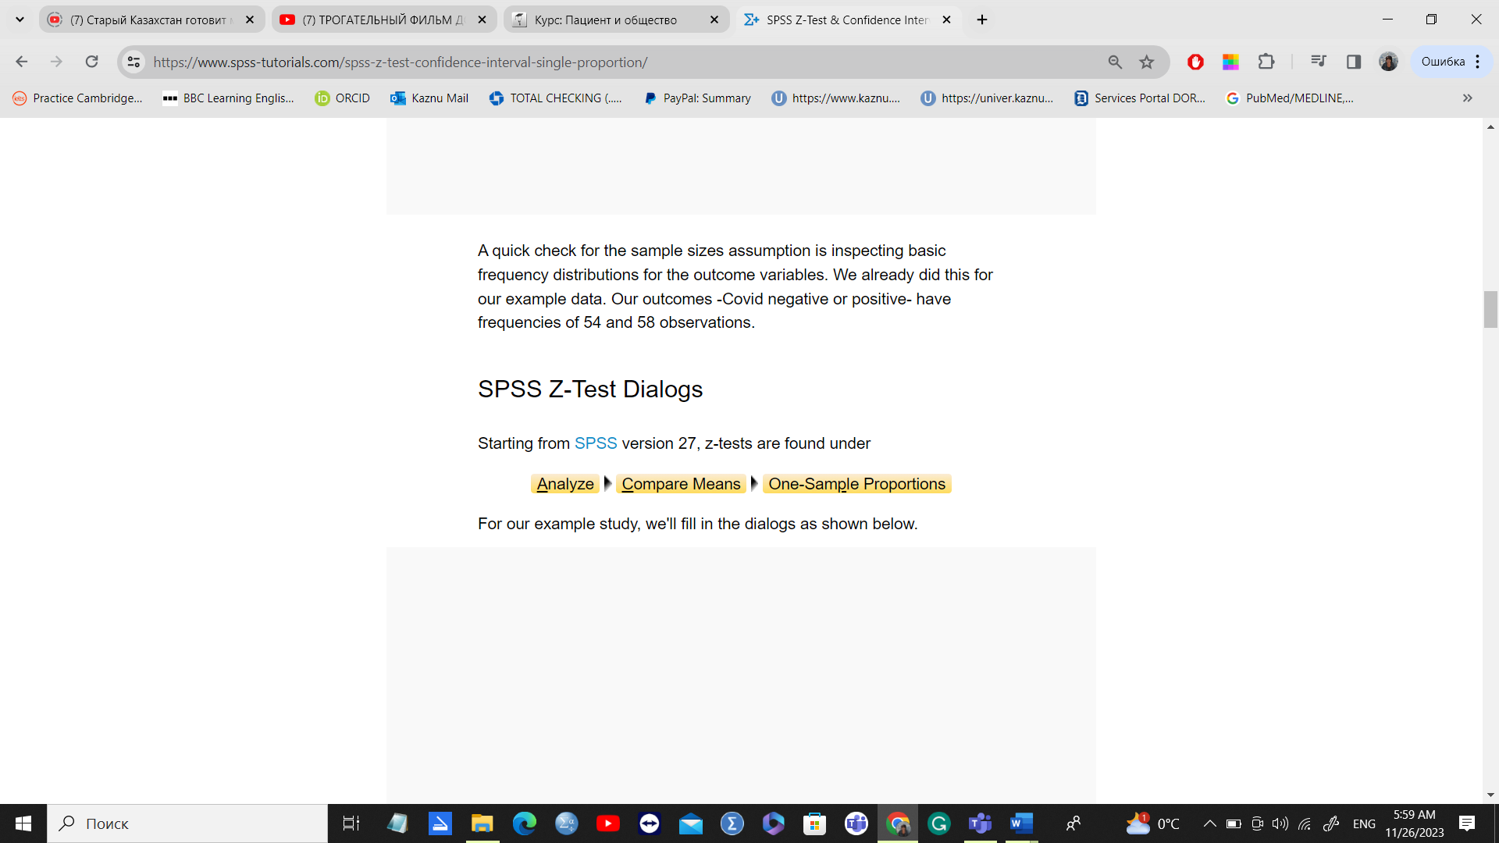
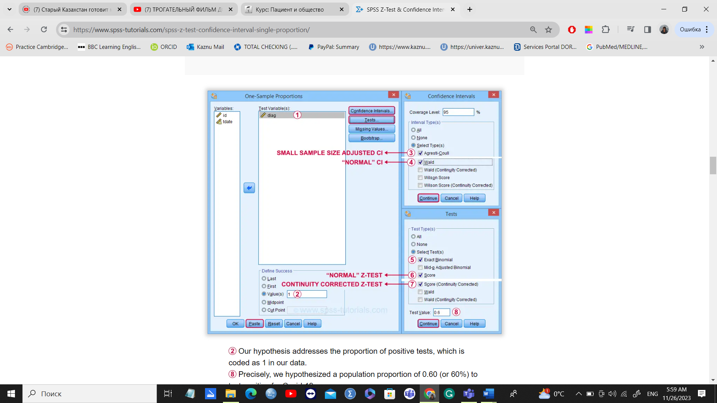
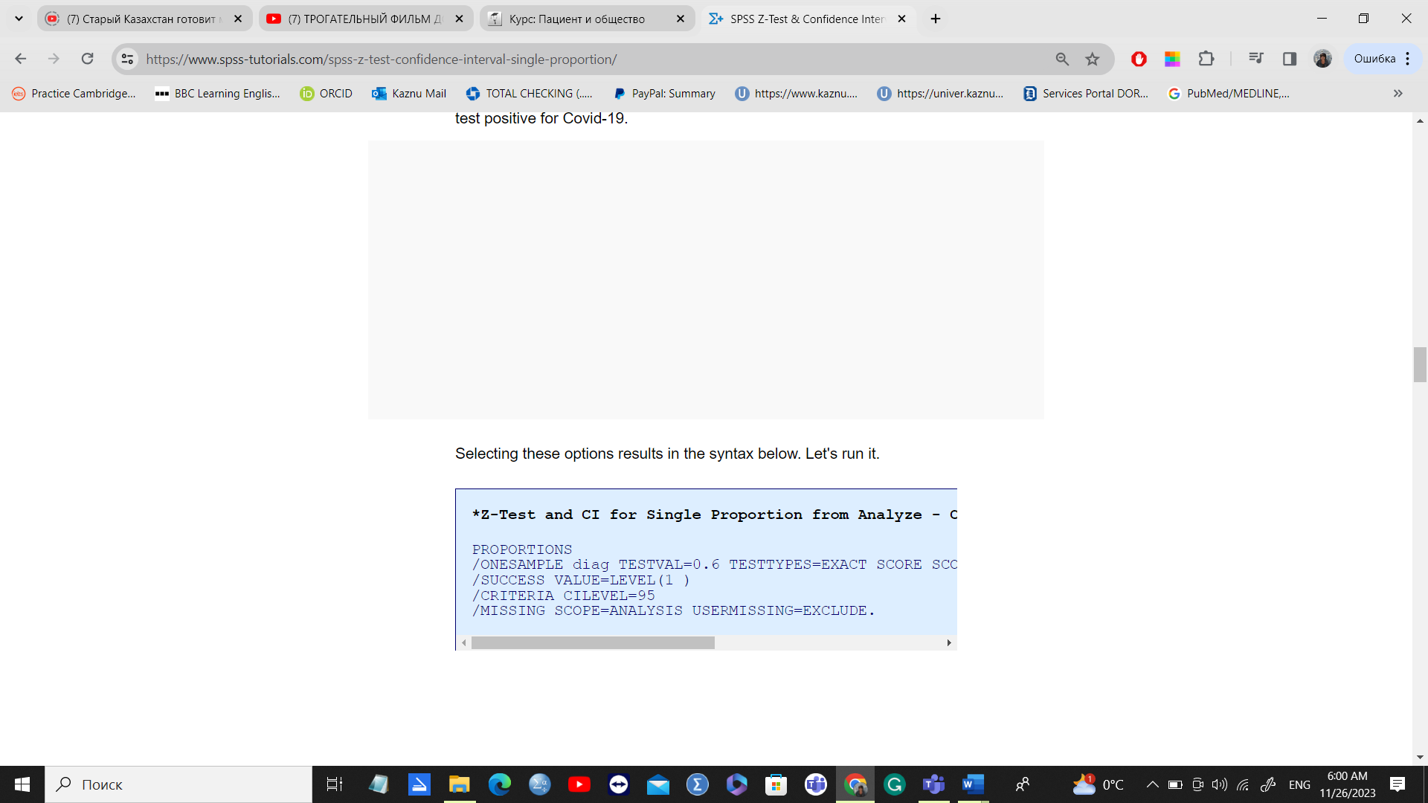
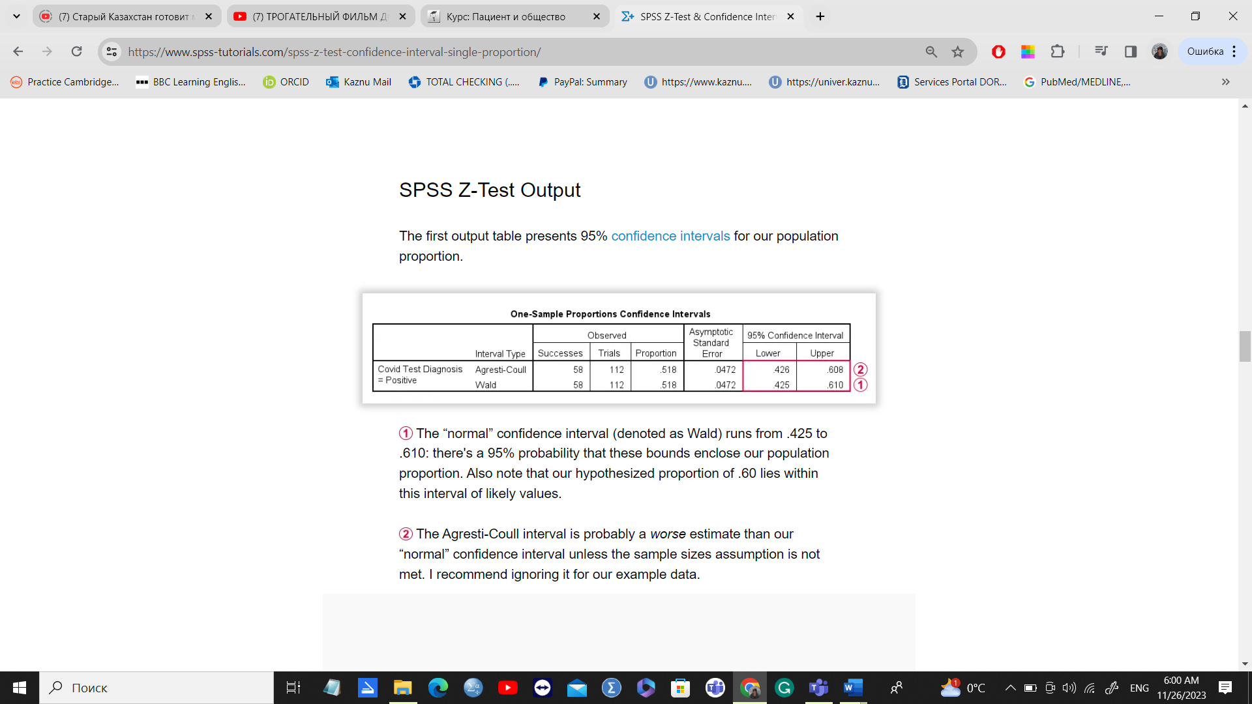
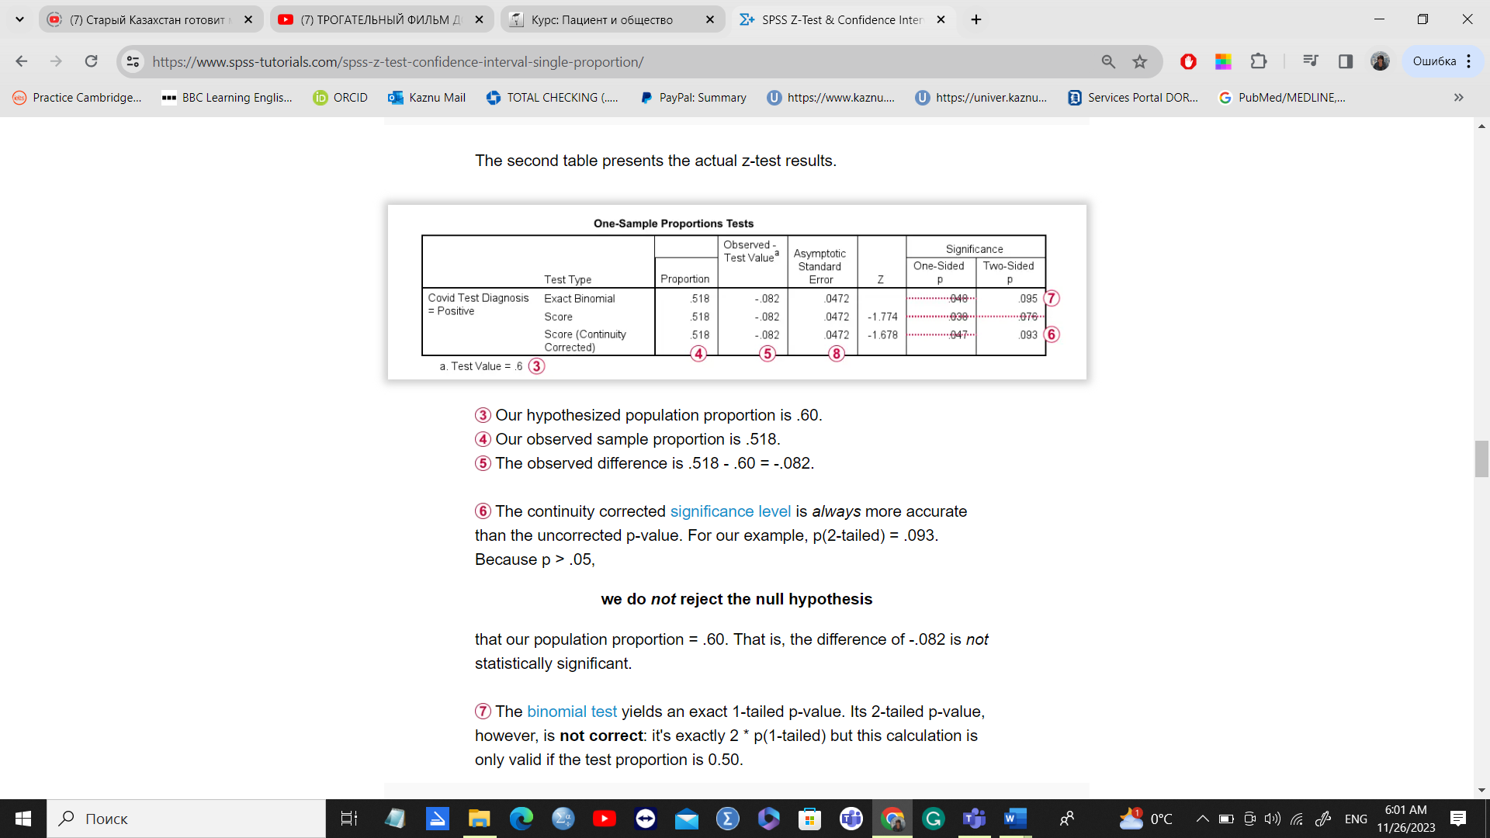
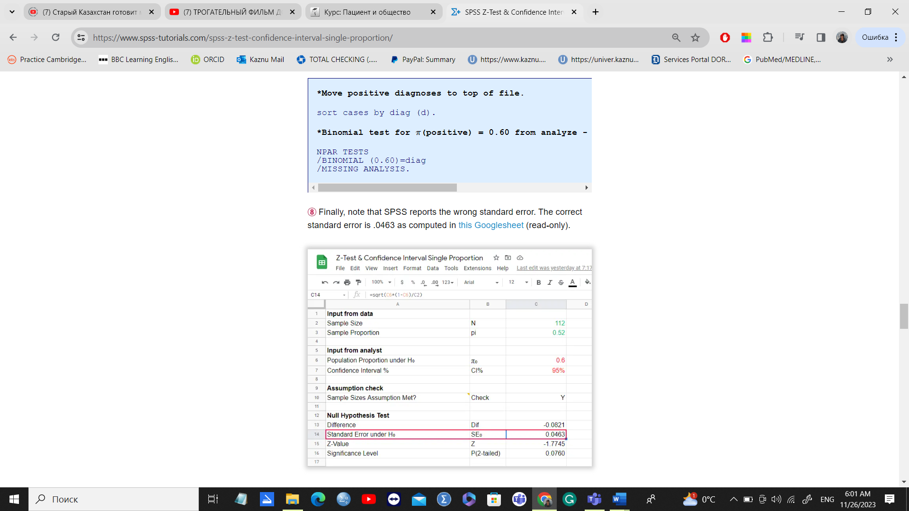
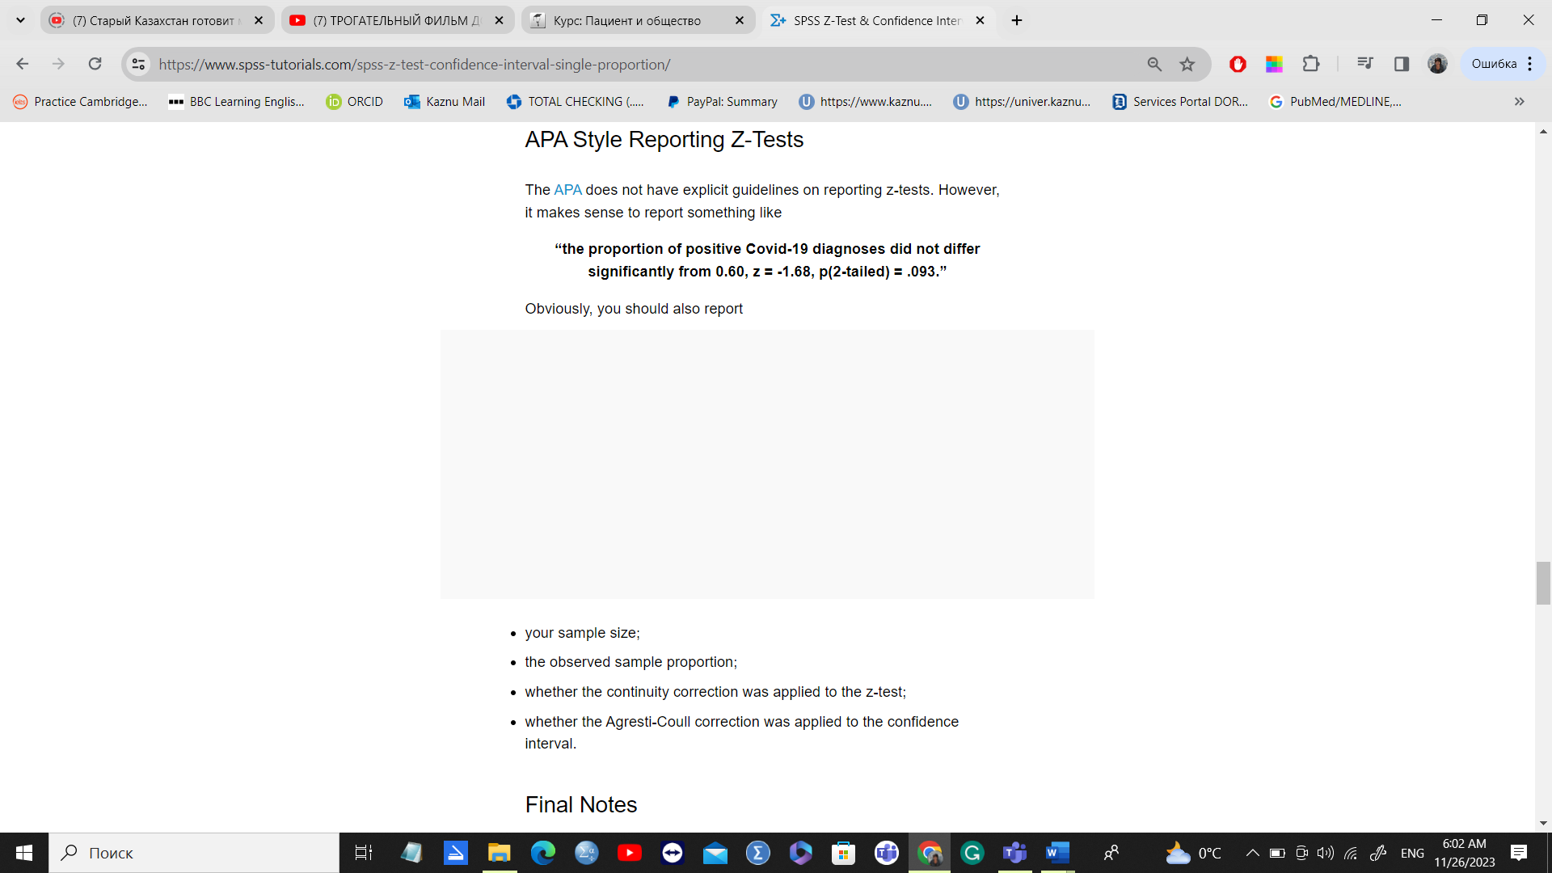
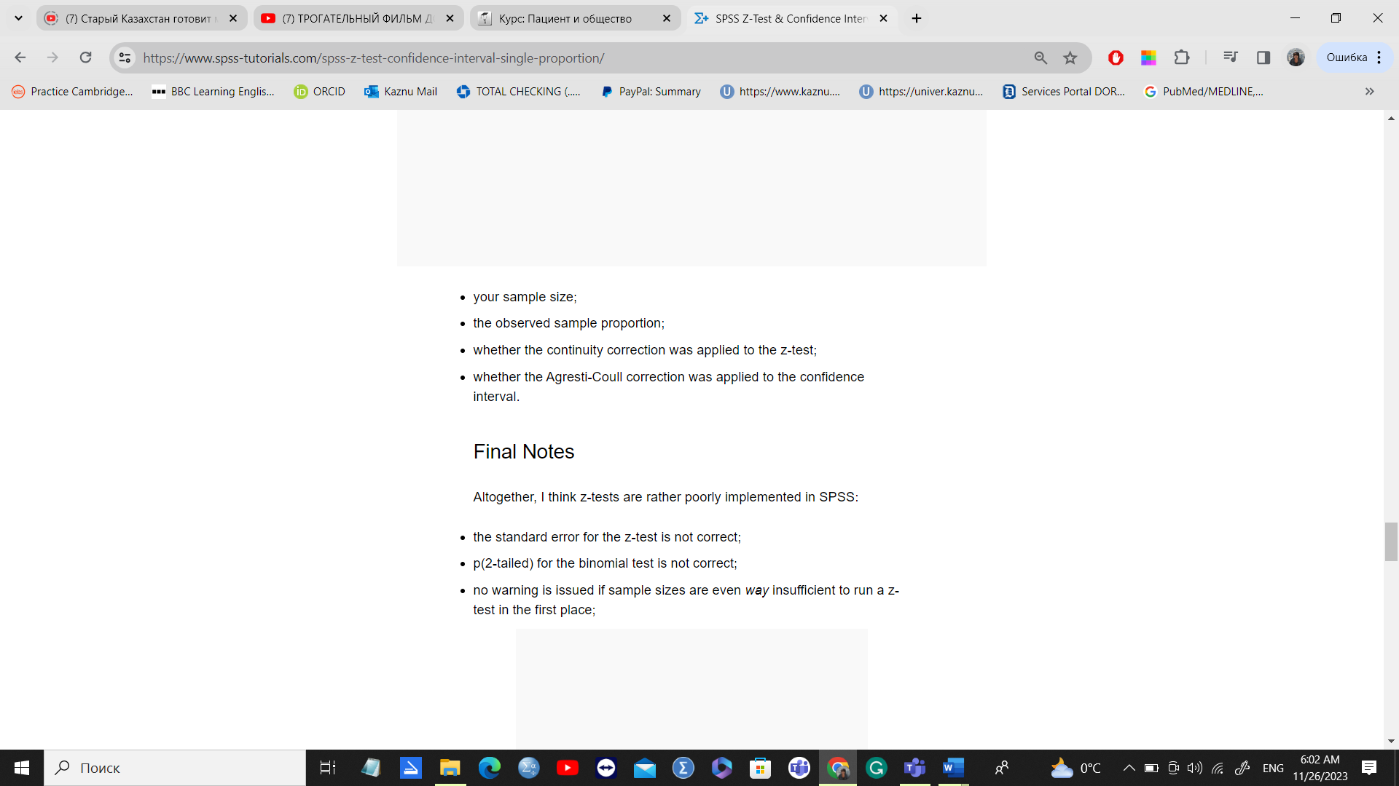

APA Style Reporting Z-Tests
The APA does not have explicit guidelines on reporting z-tests. However, it makes sense to report something like“the proportion of positive Covid-19 diagnoses did not differ significantly from 0.60, z = -1.68, p(2-tailed) = .093.”Obviously, you should also report
- your sample size;
- the observed sample proportion;
- whether the continuity correction was applied to the z-test;
- whether the Agresti-Coull correction was applied to the confidence interval.

Final Notes
Altogether, I think z-tests are rather poorly implemented in SPSS:
- the standard error for the z-test is not correct;
- p(2-tailed) for the binomial test is not correct;
- no warning is issued if sample sizes are even way insufficient to run a z-test in the first place;
- no effect size measures (such as Cohen’s H) are available;
- z-tests and confidence intervals are reported in separate tables which the end user will probably want to merge in Excel or something.
What's really good, however, is that
- z-tests in SPSS handle (even a combination of) numeric and string variables;
- several corrections for both the z-test and confidence intervals are available.
Thanks for reading!

References
- Agresti, A. & Coull, B.A. (1998). Approximate Is Better than "Exact" for Interval Estimation of Binomial Proportions The American Statistician, 52(2), 119-126.
- Agresti, A. & Franklin, C. (2014). Statistics. The Art & Science of Learning from Data. Essex: Pearson Education Limited.
- Van den Brink, W.P. & Koele, P. (1998). Statistiek, deel 2 [Statistics, part 2]. Amsterdam: Boom.

Binomial Test – Simple Tutorial
By Ruben Geert van den Bergunder Nonparametric Tests & Statistics A-Z
For running a binomial test in SPSS, see SPSS Binomial Test.
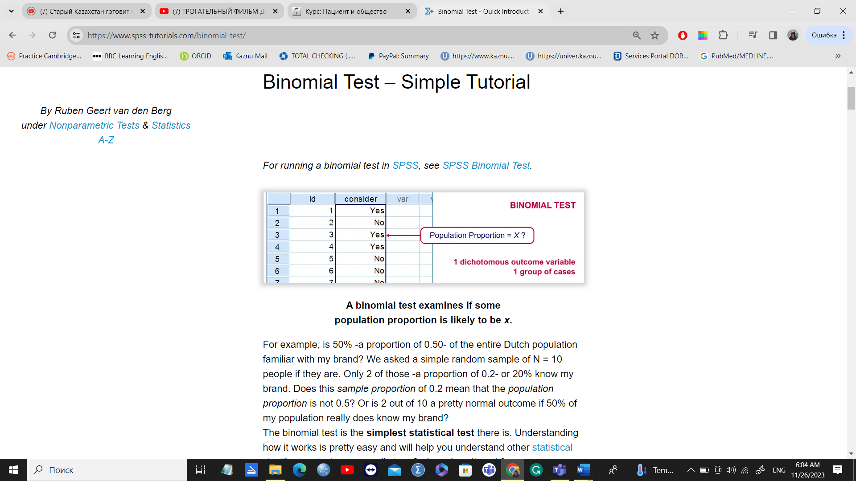
A binomial test examines if some
population proportion is likely to be x.For example, is 50% -a proportion of 0.50- of the entire Dutch population familiar with my brand? We asked a simple random sample of N = 10 people if they are. Only 2 of those -a proportion of 0.2- or 20% know my brand. Does this sample proportion of 0.2 mean that the population proportion is not 0.5? Or is 2 out of 10 a pretty normal outcome if 50% of my population really does know my brand?
The binomial test is the simplest statistical test there is. Understanding how it works is pretty easy and will help you understand other statistical significance tests more easily too. So how does it work?

Binomial Test - Basic Idea
If the population proportion really is 0.5, we can find a sample proportion of 0.2. However, if the population proportion is only 0.1 (only 10% of all Dutch adults know the brand), then we may also find a sample proportion of 0.2. Or 0.9. Or basically any number between 0 and 1. The figure below illustrates the basic problem -I mean challenge- here.

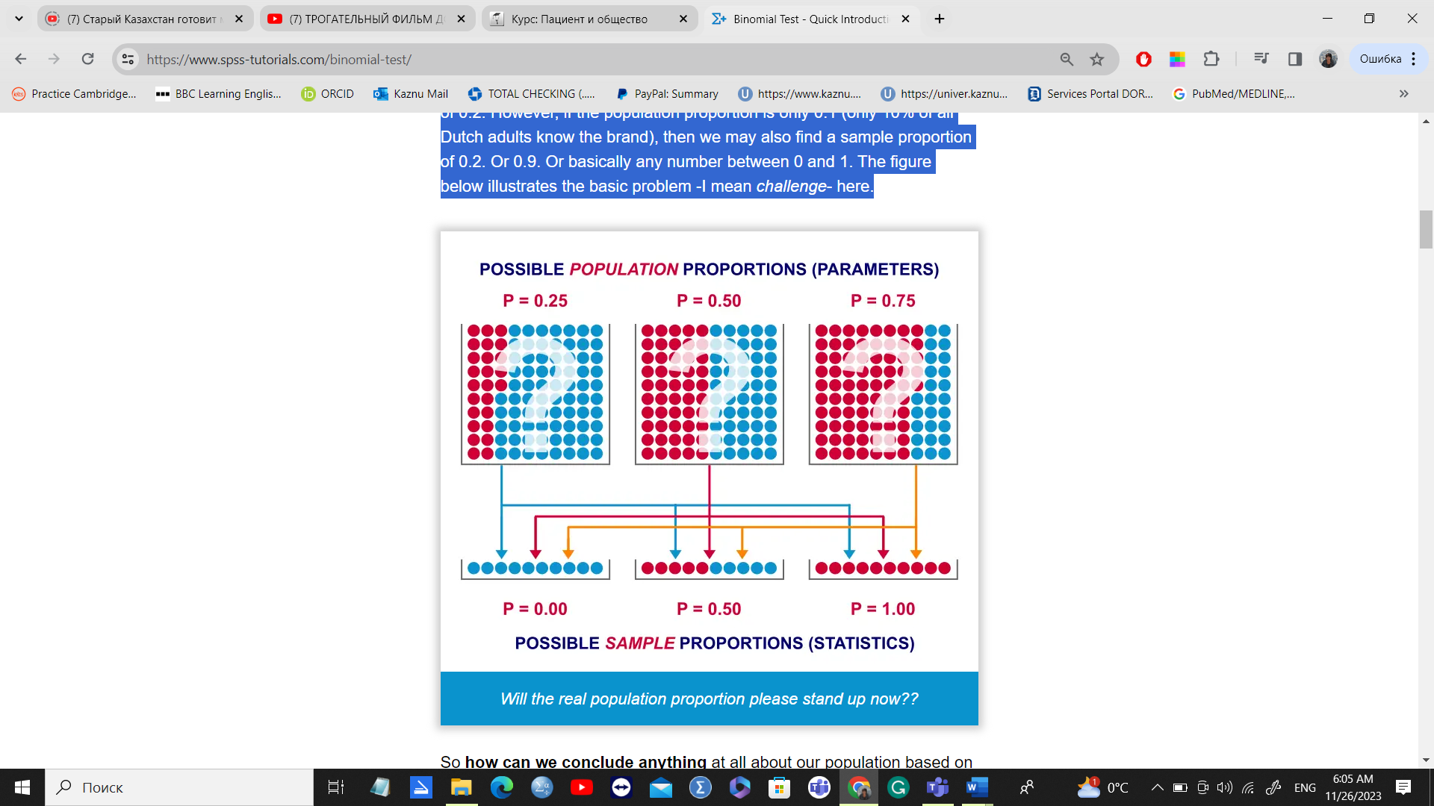
So how can we conclude anything at all about our population based on just a sample? Well, we first make an initial guess about the population proportion which we call the null hypothesis: a population proportion of 0.5 knows my brand.
Given this hypothesis, many sample proportions are possible. However, some outcomes are extremely unlikely or almost impossible. If we do find an outcome that's almost impossible given some hypothesis, then the hypothesis was probably wrong: we conclude that the population proportion wasn't x after all.
So that's how we draw population conclusions based on sample outcomes. Basically all statistical tests follow this line of reasoning. The basic question for now is: what's the probability of finding 2 successes in a sample of 10 if the population proportion is 0.5?

Binomial Test Assumptions
First off, we need to assume independent observations. This basically means that the answer given by any respondent must be independent of the answer given by any other respondent. This assumption (required by almost all statistical tests) has been met by our data.

Binomial Distribution - Formula
If 50% of some population knows my brand and I ask 10 people, then my sample could hold anything between 0 and 10 successes. Each of these 11 possible outcomes and their associated probabilities are an example of a binomial distribution, which is defined as
P(B=k)=(nk)pk(1−p)n−k�(�=�)=(��)��(1−�)�−�
where
- n� is the number of trials (sample size);
- k� is the number of successes;
- p� is the probability of success for a single trial or the (hypothesized) population proportion.
Note that (nk)(��) is a shorthand for n!k!(n−k)!�!�!(�−�)! where !! indicates a factorial.
For practical purposes, we get our probabilities straight from Google Sheets (it uses the aforementioned formula under the hood but it doesn't bother us with it).
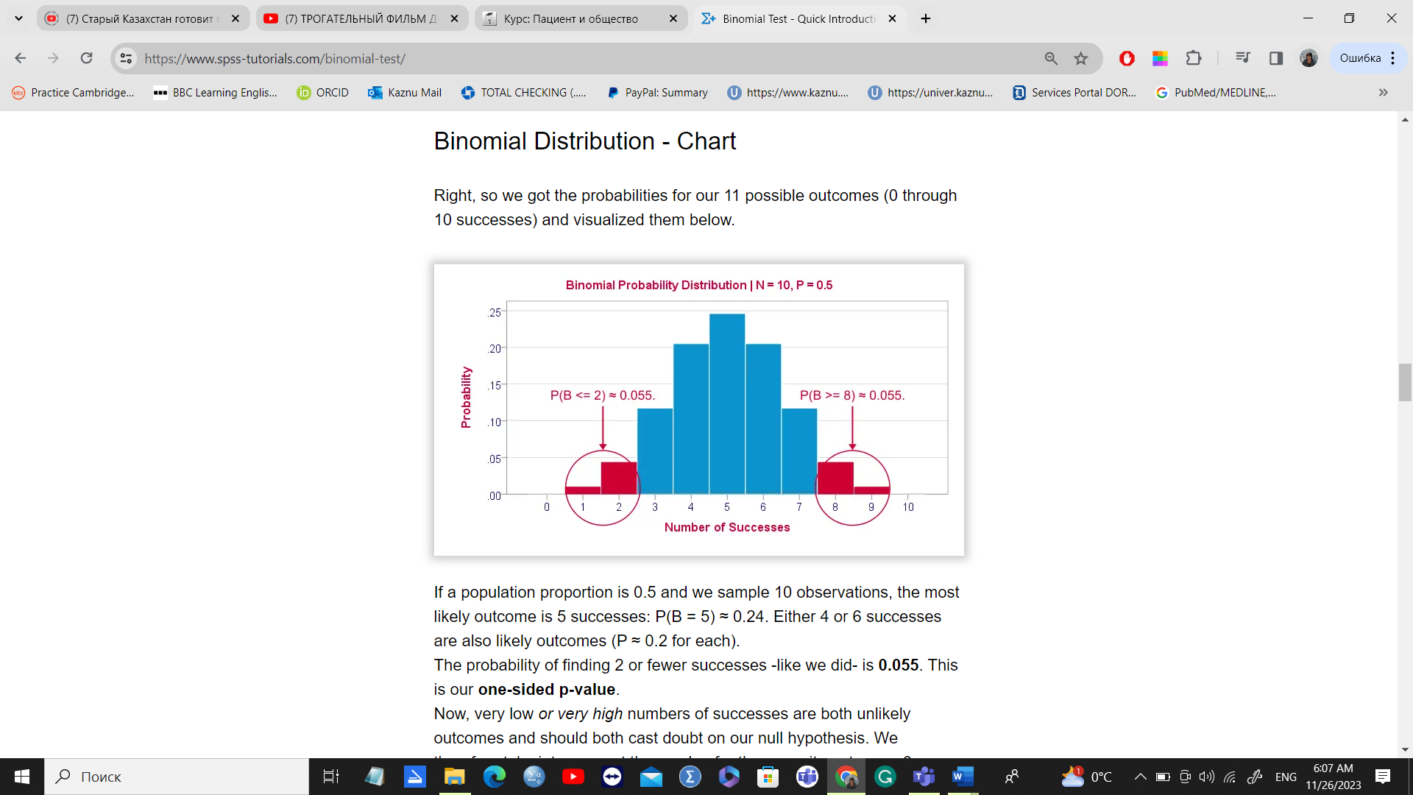
If a population proportion is 0.5 and we sample 10 observations, the most likely outcome is 5 successes: P(B = 5) ≈ 0.24. Either 4 or 6 successes are also likely outcomes (P ≈ 0.2 for each).
The probability of finding 2 or fewer successes -like we did- is 0.055. This is our one-sided p-value.
Now, very low or very high numbers of successes are both unlikely outcomes and should both cast doubt on our null hypothesis. We therefore take into account the p-value for the opposite outcome -8 or more successes- which is another 0.055. Like so, we find a 2-sided p-value of 0.11. If we would draw 1,000 samples instead of just 1, then some 11% of those should result in 2(-) or 8(+) successes when the population proportion is 0.5. Our sample outcome should occur in a reasonable percentage of samples. And since 11% is not very unlikely, our sample does not refute our hypothesis that 50% of our population knows our brand.

SPSS binomial check

1. Quick Data Check
Let's first take a quick look at the FREQUENCIES for gender. Like so, we can inspect whether there are any missing values and whether the variable is really dichotomous. We'll run some FREQUENCIES. The syntax is so simple that we'll just type it instead of clicking through the menu.
Inspect frequency distribution.
frequencies gender.
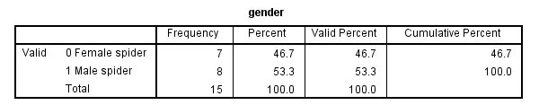

2. Assumptions Binomial Test
The results from any statistical test can only be taken seriously insofar as its assumptions have been met. For the binomial test we need just one:
- independent observations (or, more precisely, independent and identically distributed variables);
This assumption is beyond the scope of this tutorial. We presume it's been met by the data at hand.

3. Run SPSS Binomial Test
We'd like to test whether the proportion of female spiders differs from .75 (our test proportion). Now SPSS Binomial Test has a very odd feature: the test proportion we enter applies to the category that's first encountered in the data. So the hypothesis that's tested depends on the order of the cases. Because our test proportion applies to female (rather than male) spiders, we need to move our female spiders to the top of the data file. We'll do so by running the syntax below. Next, we'll run the actual binomial test.
Move Female Spiders to Top of File.
sort cases by gender.
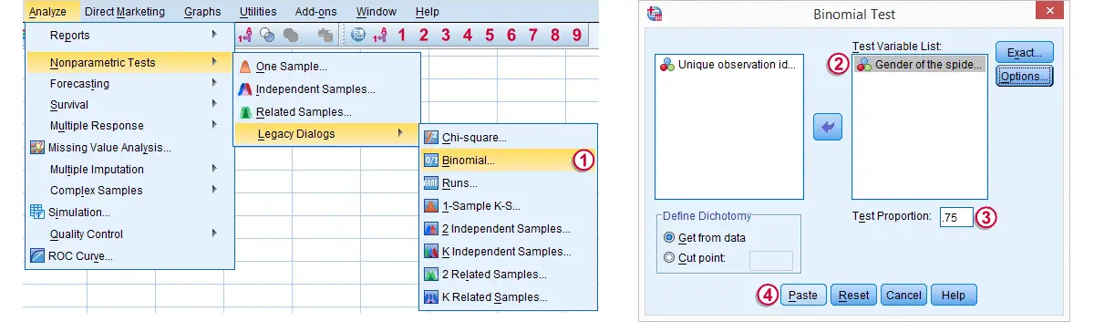
Clicking Paste results in the syntax below. We'll run it and move on the output.
Run SPSS Binomial Test.
NPAR TESTS
/BINOMIAL (.75)=gender
/MISSING ANALYSIS.

4. SPSS Binomial Test Output

Since we have 7 female spiders out of 15 observations, the observed proportion is (7 / 15 =) .47.
Our null hypothesis states that this proportion is .75 for the entire population.
The p value, denoted by Exact Sig. (1-tailed) is .017. If the proportion of female spiders is exactly .75 in the entire population, then there's only a 1.7% chance of finding 7 or fewer female spiders in a sample of N = 15. We often reject the null hypothesis if this chance is smaller than 5% (p < .05). We conclude that the proportion of female spiders is not .75 in the population but probably (much) lower.
Note that the p value is the chance of finding the observed proportion or a “more extreme” outcome. If the observed proportion is smaller than the test proportion, then a more extreme outcome is an even smaller proportion than the one we observe.* We ignore the fact that finding very large proportions would also contradict our null hypothesis. This is what's meant by (1-tailed).*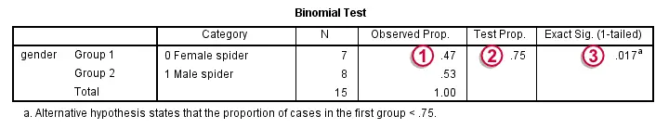

5. Reporting a Binomial Test
When reporting test results, we always report some descriptive statistics as well. In this case, a frequency table will do. Regarding the significance test, we'll write something like “a binomial test indicated that the proportion of female spiders of .47 was lower than the expected .75, p = .017 (1-sided)”.

SPSS Sign Test for One Median – Simple Example
By Ruben Geert van den Bergunder Statistics A-Z & Nonparametric Tests
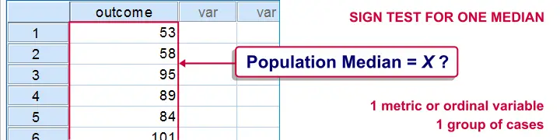
A sign test for one median is often used instead of a one sample t-test when the latter’s assumptions aren't met by the data. The most common scenario is analyzing a variable which doesn't seem normally distributed with few (say n < 30) observations. *
This tutorial shows how to run and interpret a sign test in SPSS. We'll use adratings.sav throughout, part of which is shown below.

SPSS Sign Test - Null Hypothesis
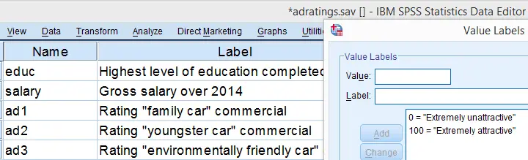
A car manufacturer had 3 commercials rated on attractiveness by 18 people. They used a percent scale running from 0 (extremely unattractive) through 100 (extremely attractive). A marketeer thinks a commercial is good if at least 50% of some target population rate it 80 or higher.
Now, the score that divides the 50% lowest from the 50% highest scores is known as the median. In other words, 50% of the population scoring 80 or higher is equivalent to our null hypothesis that
the population median is at least 79.5 for each commercial.
If this is true, then the medians in our sample will be somewhat different due to random sampling fluctuation. However, if we find very different medians in our sample, then our hypothesized 79.5 population median is not credible and we'll reject our null hypothesis.

Quick Data Check - Histograms
Let's first take a quick look at what our data look like in the first place. We'll do so by inspecting histograms over our outcome variables by running the syntax below.
Quickly check outcome variables with histograms.
frequencies ad1 to ad3/format notable/histog
ram.

Result

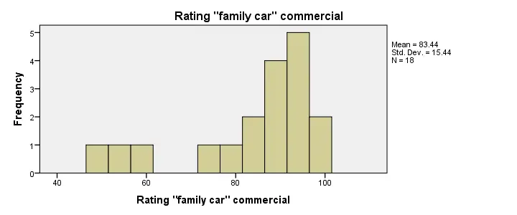

Quick Data Check - Medians
Our histograms included mean scores for our 3 outcome variables but what about their medians? Very oddly, we can't compute medians -which are descriptive statistics- with DESCRIPTIVES. We could use FREQUENCIES but we prefer the table format we get from MEANS as shown below.

SPSS - Compute Medians Syntax
Inspect medians of 3 outcome variables.
means ad1 to ad3/cells count mean median.

Result
